Products Table

The Products table contains details about products, including their names, categories, and unit

prices. It provides reference data for linking product information to sales transactions.

1. Retrieve all columns from the product table.

select * from Products;

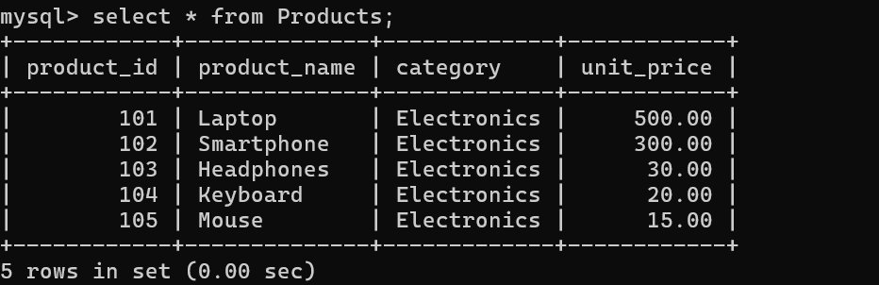

2. Retrieve the product_name and unit_price from the Products table.

select product_name,unit_price from Products;

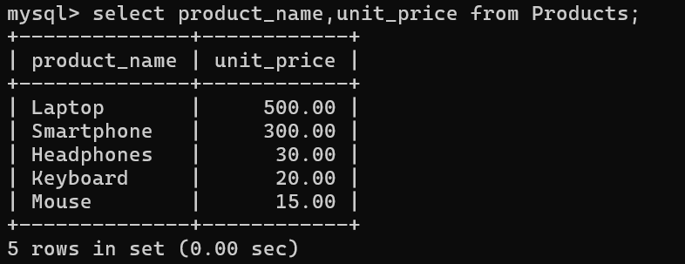

3. Filter the Products table to show only products in the ‘Electronics’ category.

mysql> select * from Products where category='Electronics';

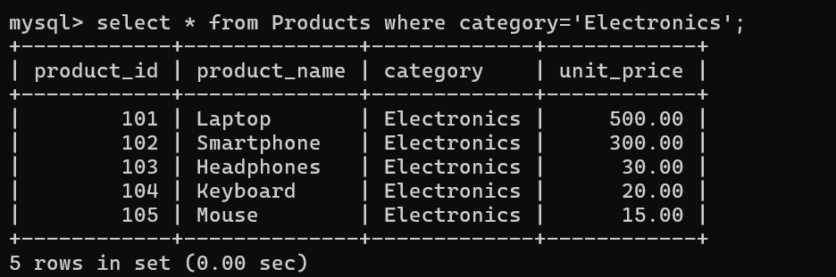

4. Retrieve the product_id and product_name from the Products table for products with a

unit_price greater than $100.

mysql> select product_id,product_name from Products where unit_price>100;

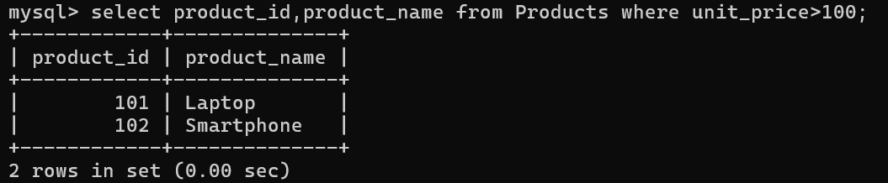

5. Calculate the average unit_price of products in the Products table.

mysql> select avg(unit_price) from Products;

6. Retrieve product_name and unit_price from the Products table with the Highest Unit Price

mysql> select product_name,unit_price from Products where unit_price=(select max(unit_price) from Products);

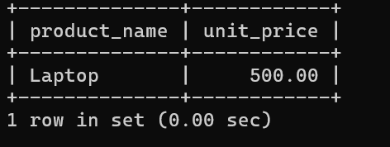

7. Retrieve the product_name and unit_price from the Products table, ordering the results by

unit_price in descending order.

mysql> select product_name,unit_price from Products order by unit_price desc;

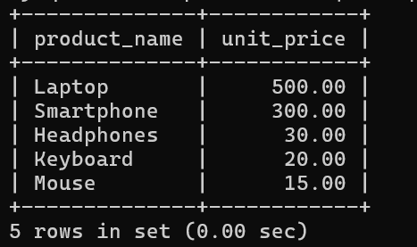

8. Retrieve the product_name and unit_price from the Products table, filtering the unit_price to

show only values between $20 and $600.

mysql> select product_name,unit_price from Products where unit_price>20 AND unit_price<600;

9. Retrieve the product_name and category from the Products table, ordering the results by

category in ascending order.

mysql> select product_name,category from Products order by category asc;

